# Testing for proper NCGMP09 database conversion

1. Open ArcMap
2. Open NCGMP Database (read KB *Open NCGMP Database)*
3. Start editing
4. Select Manage Map Unit Legend from NCGMP drop-down

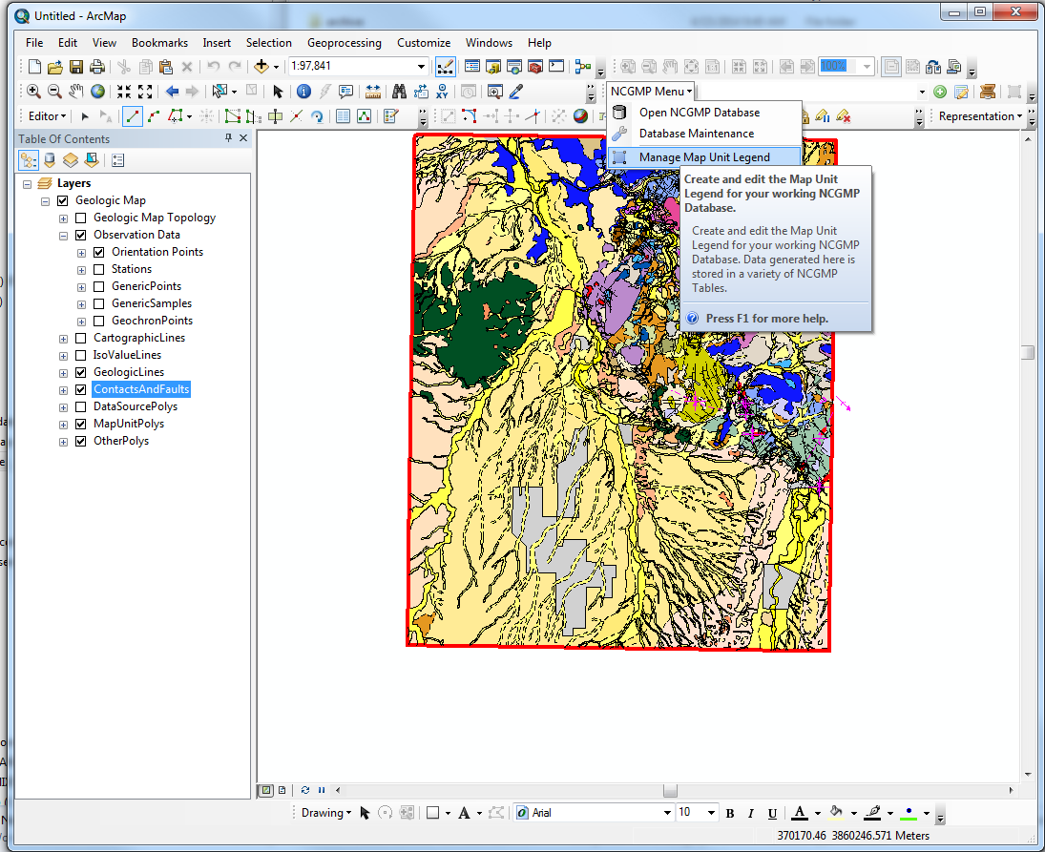

1. Click on legend item. Try editing something and click save.
2. Stop Editing
3. If any of these things fail, go back to the DMU table and see if you can figure out what the problem is.

